FINAL REPORT
Experiment 3: Dimensional Modeling and Star Schema Design using Microsoft Power BI
Objective
The objective of this experiment was to organize the Global Superstore transactional data into a dimensional model using Microsoft Power BI and create a Star Schema for efficient business analysis and reporting.
Work Completed
In this experiment, we worked with the Global Superstore dataset and analyzed the available business information to separate measurable transactional data from descriptive information.
The transactional information was organized into a central Fact_Sales table containing fields such as Order ID, Customer ID, Product ID, Region, Order Date, Sales, Quantity, Profit, and Discount.
The descriptive information was organized into separate dimension tables:
- Dim_Customer – customer details and segment information.
- Dim_Product – product, category, and sub-category information.
- Dim_Region – region, country, state, and city information.
- Dim_Date – date, year, quarter, and month information.
Duplicate records were removed from the dimension tables to maintain proper relationships with the fact table.
Star Schema
The Fact_Sales table was used as the central table and was connected to the dimension tables through their respective keys. The relationships were configured as Many-to-One, allowing the dimension tables to filter the transactional data correctly.
This created a Star Schema that made the data model more organized and easier to use for analytical reporting.
Analytical Measures
DAX measures were created to calculate important business metrics:
- Total Sales
- Total Profit
- Profit Margin
- Average Order Value
These measures were used to analyze the sales and profitability of the business from different dimensions.

Final Outcome
The dimensional model was successfully created in Power BI. The Global Superstore data was organized into a central fact table and multiple dimension tables, forming a Star Schema. The model was validated using reports such as Sales by Category, Profit by Region, and Sales Trend by Year.

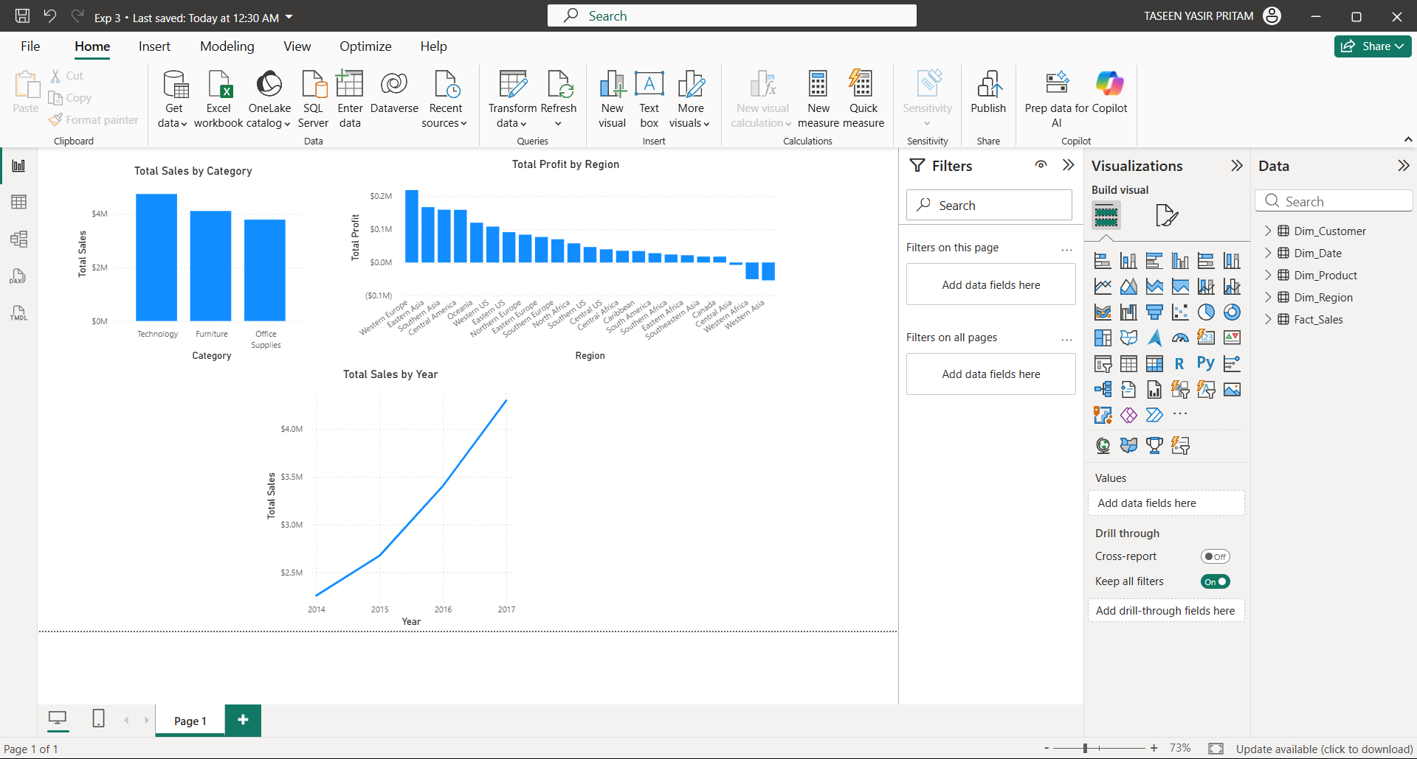

Conclusion
This experiment gave us practical experience in designing a dimensional model using Power BI. We learned how to distinguish between Fact and Dimension tables, create relationships between them, and use DAX measures for analysis. The final Star Schema provided a structured and efficient model for business reporting and decision-making.

